
TBCL Solar Marketplace – Technology Manual
[Content for print and digital (pdf) versions]
________

About TBCL Solar Marketplace
QR code for print version
What is TBC Leasing’s Digital Solar PV marketplace?
TBC Leasing’s Digital Solar PV Marketplace [insert link for pdf version] is an online platform specifically designed for customers who are planning to install a solar PV system to benefit from renewable energy sources and reduce their electricity expenses. The platform brings together potential customers and reliable solar PV suppliers that have been carefully selected by TBC Leasing. It provides support to customers throughout the investment process. You can invest in Solar PV technology in the following easy steps and save time:
- Register and submit a request for a solar PV system.
- Receive quotes from reputable suppliers for equipment, services, and warranties.
- Compare the offers and select the best option that meets your requirements.
- Receive a financing offer from TBC Leasing tailored to your project and the supplier's offer.

Why use TBC Leasing's Digital Solar Marketplace?
- Preselected Reliable Supplier: TBC Leasing has already preselected a reliable partner supplier, saving you the time and effort of finding one yourself.
- Convenient Information Access: Easily obtain information on solar PV technology through the platform, eliminating the need for time-consuming research.
- Investment Cost Estimation: Use the Solar PV and Leasing calculator available on the platform to quickly estimate your investment costs and benefits, saving you time and effort.
- Online Application: No need to visit TBC Leasing's office; you can make your application conveniently online.
- Quote Comparison: Easily compare quotes from different suppliers, ensuring you select the best offer that suits your requirements.
- Financing Proposal: Receive a financing proposal from TBC Leasing based on your specific request, simplifying the financial aspect of your solar PV system investment.
- Digitalized Process: The entire pre-investment process is digitalized, providing a seamless and efficient experience for customers.

Solar PV Technology and its benefits
What is solar PV technology and how does it work?
Solar photovoltaic (PV) technology, also known as solar panels, is a renewable energy technology that converts sunlight into electricity. The technology consists of two key components: solar PV panels and an inverter.
Solar PV panels generate electricity when exposed to sunlight. The role of the solar PV panel is to capture sunlight and convert it into DC (direct current) electricity. The panels are typically installed on rooftops or other suitable locations with maximum sunlight exposure.
The inverter is a critical component of the solar PV system. Its main function is to convert the DC electricity generated by the panels into AC (alternating current) electricity, which is the type of electricity used in most households and businesses.
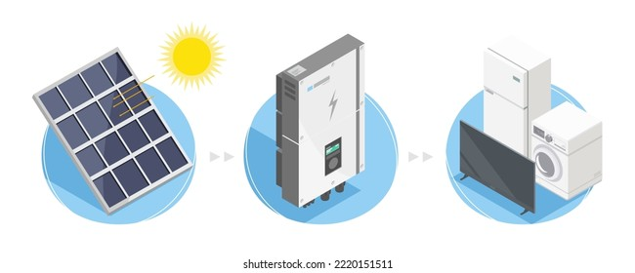
https://www.shutterstock.com/image-vector/solar-cell-icon-symbols-system-concept-2220151511
The lifespan of solar PV technology varies depending on the quality of the panels and their maintenance, but on average they can last 25 to 30 years or more, making it a reliable and sustainable source of renewable energy.
What are the benefits of using solar energy?
Solar energy offers numerous benefits, making it a popular choice for renewable energy:
- Renewable and Sustainable: Solar energy is a clean, renewable energy source that can be harnessed as long as the sun shines, making it a sustainable option.
- Cost Savings: Solar energy can significantly reduce electricity bills over time, providing long-term cost savings once the initial investment is recovered.
- Energy Independence: By generating their own electricity, small-scale solar PV stations can reduce dependence on the grid and increase self-sufficiency in meeting energy needs.
- Minimal Maintenance: Solar PV systems require only minimal maintenance, lowering operating costs compared to other power generation methods and providing durability and reliability.
- Environmental Friendliness: Solar energy produces no greenhouse gas emissions or air pollutants during operation, helping to reduce carbon footprints and protect the environment.
- Durability and Longevity: Solar panels have a long lifespan of 25-30 years, providing a stable and reliable source of electricity for an extended period.
- Silent Operation: Solar PV systems operate silently, without generating noise pollution, making them suitable for residential or noise-sensitive areas.
- Enhanced Reputation: Adopting solar energy can enhance the reputation of businesses by showcasing their commitment to sustainability and environmental responsibility.

Types of solar PV systems
There are three main types of solar PV (photovoltaic) systems: on-grid, off-grid, and hybrid.
On-grid solar PV system: This type of system is connected to the utility grid, allowing users to generate their own electricity from solar panels and also draw electricity from the grid when solar power is not sufficient. Conversely, when the solar panels generate excess electricity, it can be fed back into the grid, earning credits or compensation through a process called net metering. On-grid systems are most commonly used in urban or suburban areas where there is a reliable grid connection. They are cost-effective and do not require expensive battery storage, since the system seamlessly switches between solar generation and grid electricity as needed.
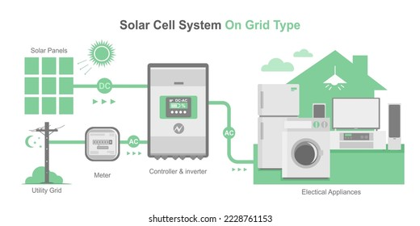
https://www.shutterstock.com/image-vector/on-grid-type-solar-cell-simple-2228761153
Off-grid solar PV system: This type of system is not connected to the utility grid and operates independently, typically using battery storage to store excess electricity generated during the day for use at night or during periods of low sunlight. Off-grid systems are suitable for remote or rural areas where there is no access to the grid, providing electricity in a stand-alone manner. However, they require careful sizing and management of battery storage to ensure reliable power supply.
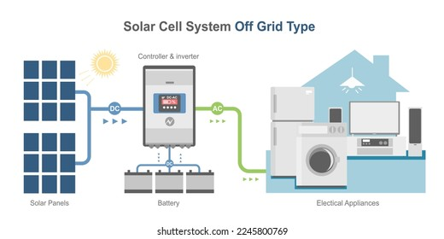
https://www.shutterstock.com/image-vector/off-grid-solar-cell-simple-diagram-2245800769
Hybrid solar PV system: This type of system combines elements of both on-grid and off-grid systems, utilising both grid connection and battery storage. Hybrid systems can store excess electricity in batteries for use during periods of low sunlight or power outages, while also being able to feed excess electricity back into the grid. Hybrid systems provide flexibility and reliability, making them suitable for areas with unreliable grid connections or for users who require uninterrupted power supply.
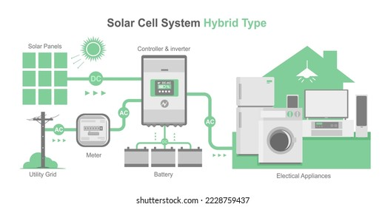
https://www.shutterstock.com/image-vector/hybrid-type-solar-cell-simple-diagram-2228759437

What types of solar panels are available?
There are several types of solar panels available, each with its own characteristics and applications. Here are some common types:
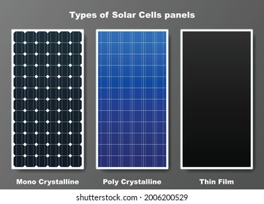
https://www.shutterstock.com/image-vector/types-solar-cell-panels-graphic-vector-2006200529
- Monocrystalline Silicon (Mono-Si) Panels: These solar panels are made from single-crystal silicon wafers, giving them a uniform black appearance. They have high efficiency and perform well in low-light conditions. Mono-Si panels are commonly used in residential and commercial installations.
- Polycrystalline Silicon (Poly-Si) Panels: These panels are made from multiple silicon crystals and have a speckled blue appearance. They are less expensive to produce than monocrystalline panels but have slightly lower efficiency. Poly-Si panels are also commonly used in residential and commercial installations.
- Thin-Film Solar Panels: Thin-film panels are made by depositing thin layers of semiconductor materials on a substrate such as glass, plastic, or metal. They are lightweight, flexible, and can be produced in different colours. Thin-film panels are less efficient than crystalline panels but can perform better in low-light conditions.
- Bifacial Solar Panels: Bifacial panels can capture sunlight from both sides, increasing their energy generation. They have a transparent backsheet that allows light to pass through, enabling the absorption of reflected sunlight from the ground or other surfaces. Bifacial panels are often installed in elevated positions or on surfaces that can reflect light, such as white rooftops or light-coloured ground cover.
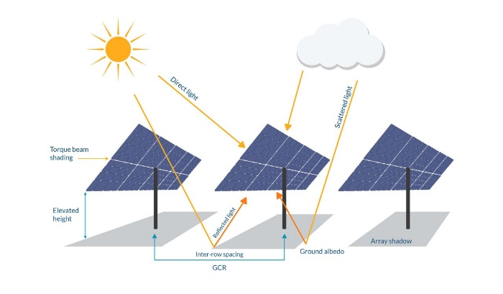
- Concentrated Solar Panels: Concentrated solar panels use lenses or mirrors to concentrate sunlight onto a smaller area of solar cells. This technology is commonly used in large-scale solar power plants, where the concentrated sunlight generates high temperatures that drive turbines for electricity production.
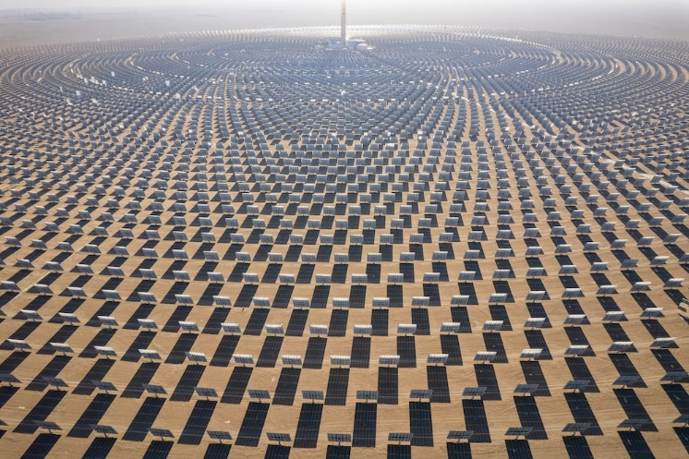
https://unsplash.com/photos/b3e_3ZBgz68
- Building-Integrated Photovoltaics (BIPV): BIPV refers to solar panels that are integrated into building materials such as windows, roofs, or facades. These panels serve a dual purpose of generating electricity while providing the functional characteristics of the building material.
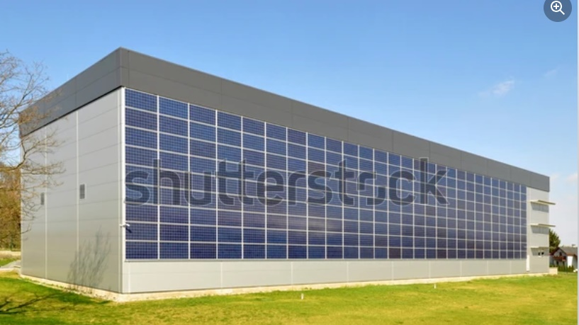
https://www.shutterstock.com/image-photo/building-integrated-photovoltaics-75165010
It is worth noting that the solar panel industry continues to innovate, and new technologies and variations are regularly introduced. The types mentioned above represent some of the most common and established options available. Not all these types may be available in Georgia, so please check with the supplier.

Project designed to fit my needs
What is the required installed capacity of a solar PV system for my needs?
To determine the required installed capacity of a solar PV system for your needs, you can perform a simple calculation.
- Firstly, assess your annual electricity consumption in kilowatt-hours (kWh) by adding up all your electricity bills over the course of a year.
- Next, divide your annual electricity consumption(kWh) by the amount of electricity produced (kWh) by a 1 kW solar PV system in your location to get the required installed capacity of the solar PV system in kilowatts (kW). To find out the amount of electricity produced (kWh) in your location by a 1 kW solar PV system, you can either use the “Solar PV and Leasing calculator” available on the platform, or use available online resources, such as Global Solar Atlas or Photovoltaic Geographical Information System.
For example, if your annual electricity consumption is 10,000 kWh and, in your location, a 1 kW solar PV system can produce 1,275 kWh annually, the required installed capacity of your solar PV system would be 7.84 kW:
- Required installed capacity (kW) = 10,000 kWh / 1,275 kWh = 7.84 kW
For such estimations you can use the “Solar PV and Leasing calculator” available on the platform.

How much energy can a solar panel produce?
The amount of energy a solar panel can produce depends on various factors, such as its capacity, efficiency, location, and weather conditions. For example, consider a solar PV system with a capacity of 1 kW (kilowatt) installed in Tbilisi. It can produce around 1,275 kWh (kilowatt-hours) of electricity per year.
However, actual energy production can vary depending on factors such as panel orientation, tilt angle, shading, temperature, and maintenance. It is important to note that solar panels generate electricity only during daylight hours when exposed to sunlight, and generation is typically highest during the summer months when sunlight is more abundant. For more detailed information on solar energy production, please use the “Solar PV and Leasing calculator” available on the platform.
Does the location of my property affect solar PV performance?
The location of your property plays a crucial role in the performance of solar PV systems. Factors such as sunlight exposure, latitude, climate, shading, panel orientation and angle, altitude, and pollution levels affect how much energy solar panels can produce. For more detailed information on solar energy production in different locations, please use the “Solar PV and Leasing calculator” available on the platform.
Where can a solar PV system be installed?
Solar PV systems can be installed in various locations, including rooftops and on the ground.
Rooftop installations are common and panels can be installed on different types of roofs, such as flat roofs, sloped roofs, and metal roofs. Flat roofs may require additional mounting systems, while sloped roofs can use tilted racks to optimise the panel angle.
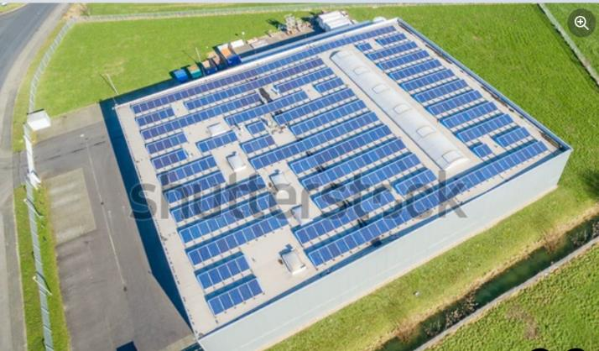
https://www.shutterstock.com/image-photo/aerial-photovoltaic-power-plant-on-roof-383614639
Ground-mounted installations are another option, suitable for properties with ample open space. Ground-mounted systems typically use racks or poles to mount the solar panels at an optimal tilt angle for maximum sunlight exposure. The specific location and type of installation depend on the available space, orientation, and tilt angle of the surface, as well as regulations.
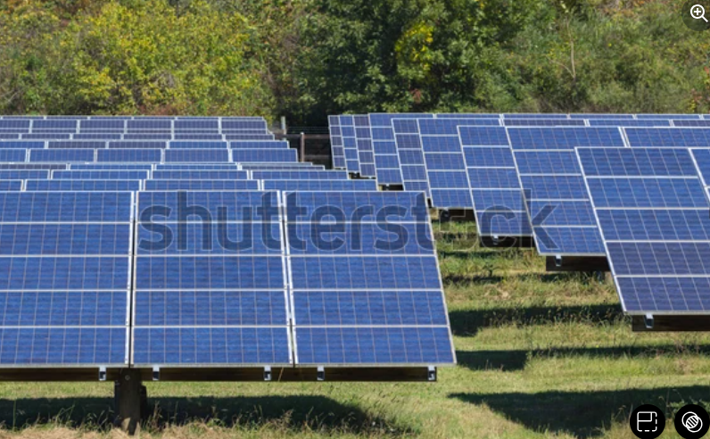
https://www.shutterstock.com/image-photo/solar-photovoltaic-system-under-harsh-north-334452176

How many solar PV panels will I need?
A typical solar panel size is around 2.6m², and its capacity can range from 500 to 550 watts. For example, if your energy consumption is 5,000 kWh per year, you may need approximately 9-10 panels to generate enough electricity to meet your needs. However, it is important to note that these estimates may vary based on location, panel efficiency, shading, and other factors.
How much space is required for a solar PV system?
The space required for a solar PV system depends on various factors, such as the number and size of panels, panel orientation, tilt angle, shading, and local regulations. As a rough estimate, a solar PV system typically requires about 5-6m² of space for every kilowatt (kW) of installed capacity in a rooftop installation. For example, if you are planning to install a 5-kW solar PV system on your roof, you would need approximately 25-30m² of available roof space.
For ground-mounted installations, the space required can vary depending on the specific design and layout. As a general guideline, ground-mounted systems typically require around 6-7m² of space per kilowatt (kW) of installed capacity (due to the need to maintain proper distance between the rows of panels to avoid shading). However, it is important to note that these are approximate estimates and actual space requirements may vary based on site-specific factors.
How long does it take to install a solar PV system?
The installation timeline for a solar PV system can vary depending on multiple factors, such as the size of the system, complexity of the installation, and availability of materials and labour. On average, a residential solar PV system installation can take anywhere from a few days to a couple of weeks. Larger commercial installations may take longer (on average up to three months) due to their scale and complexity.
The installation process typically involves several steps, including site assessment, design, permitting, equipment procurement, installation of panels, wiring, and connection to the grid.
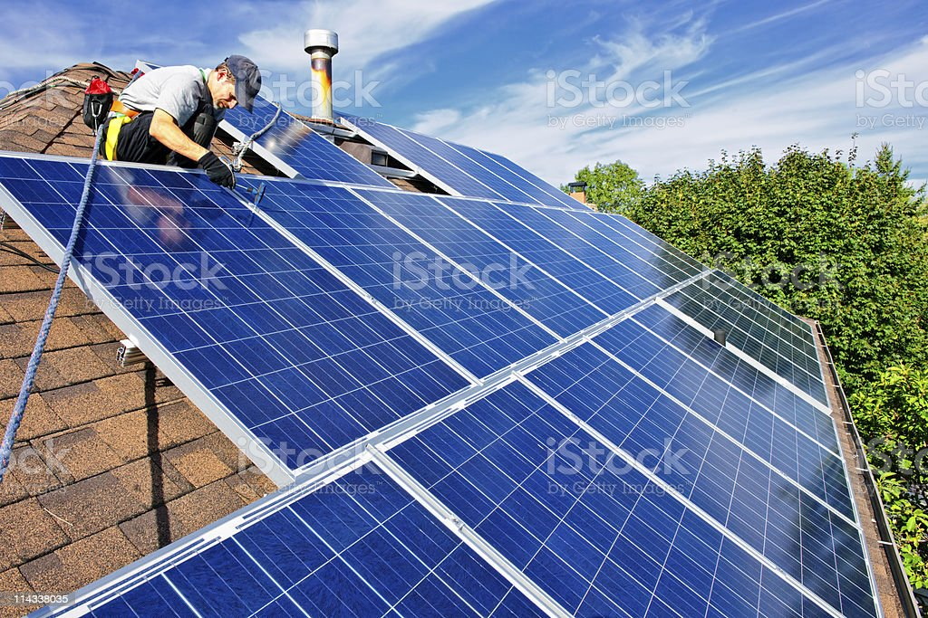
https://www.istockphoto.com/photo/solar-panel-installation-gm114338035-14578479?phrase=solar+pv+installation

What does an investment in solar PV include?
An investment in a solar PV system typically consists of three main components: solar panels, inverters, and installation.
Solar panels are the primary component of the system, generating electricity from sunlight. Inverters are necessary for converting the DC electricity produced by the panels into AC electricity that can be used in homes or businesses. While the costs of solar panels and inverters can be estimated based on the number of pieces of equipment and unit prices, installation costs can vary greatly and are best assessed during a site visit and in the design stage. Factors such as system size, location, and complexity of the installation can impact installation costs, which may include labour charges for site assessment, design, permitting, panel mounting, wiring, and grid connection. Additionally, installation costs may also encompass equipment mounting hardware, wiring materials, and electrical components, and can be influenced by variables such as roof or ground mount type, distance from the utility grid, and necessary upgrades to electrical infrastructure. On average, installation costs can range from 20-30% of the total investment cost for a solar PV system. For estimation of the investment cost, please use the “Solar PV and Leasing calculator” available on the platform.

Georgia specifics – net metering, suppliers and financing
What is a net-metering system and how does it work?
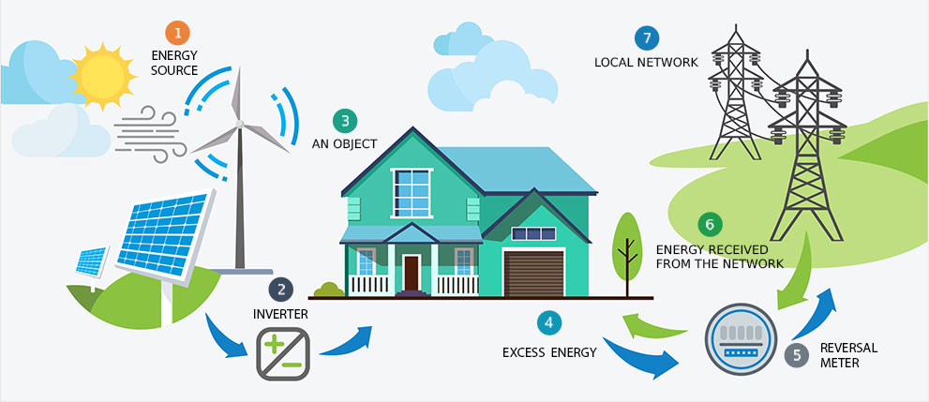
Source: https://gnerc.org/en/user-page/useful-information-for-customers/netoaghritskhva/59
Net metering is an arrangement that allows consumers who generate their own renewable energy, such as solar power, to receive credits for any excess electricity they produce and feed back into the grid. These credits are applied to the consumer's account and can be used to offset their future electricity consumption.
One key feature of net metering is the ability to carry credits forward. If a consumer generates more electricity than they use in a billing period, the excess electricity is credited to their account and can be carried forward to future billing periods. This helps consumers offset their electricity usage during times when their renewable energy system may not generate enough electricity, such as during winter months with reduced sunlight.
Net metering is available to a wide range of consumers, including residential, commercial, and groups of consumers. The solar PV system may not necessarily be owned by the consumer(s) but can be leased or rented through temporary agreements. Additionally, electricity generation and consumption of the generated electricity can occur at different locations, as long as the solar PV system and the customer/group of customers are connected to the same distribution company.
There are caps on the maximum capacity of renewable energy systems eligible for net metering, set at 30 kW for residential customers and 500 kW for commercial and industrial customers. Moreover, the excess electricity generated by consumers is credited at the wholesale rate, which is lower than the retail rate at which consumers are charged for electricity. This means that consumers may not receive the full retail value for their excess electricity. For more information on net metering systems and related processes, please visit the official web page of Georgian National Energy and Water Supply Regulatory Commission (GNERC) at the following link: https://gnerc.org/

Which solar PV panels are available in Georgia?
In Georgia, solar PV panels are available from diverse manufacturers, with the most common sources being Germany and China. In the local market, the solar PV panels available from Georgian suppliers are predominantly monocrystalline and polycrystalline types. When comparing German and Chinese solar PV panels, several factors should be considered. Firstly, German-made solar panels are known for their high quality, durability, and advanced technology. German manufacturers have a long-standing reputation for producing reliable and efficient solar panels. German panels often come with premium prices but are known for their performance and reliability.
On the other hand, Chinese-made solar panels are generally more affordable due to lower production costs. Chinese manufacturers are known for their competitive pricing. However, Chinese panels have historically been associated with variable levels of quality and performance, and it is important to carefully evaluate the specific brand and model. In recent years, Chinese-made panels have made significant advancements in terms of performance, efficiency, and reliability. Many Chinese manufacturers have adopted technologies and expertise from Germany and the US to improve their products. This has resulted in more cost-effective solar panels which are now able to compete with German panels in terms of performance and reliability.
How can I finance my solar PV system?
TBC Leasing offers a convenient and flexible financing solution for solar PV systems, supported by the TBCL Solar Marketplace, an online platform designed to guide and support customers throughout the investment process. Through TBCL Solar Marketplace, you can register and submit a request, obtain quotes from TBC Leasing’s reputable partner suppliers for equipment, services, and warranties, and then select the best offer that meets your requirements. TBC Leasing prepares a financing offer based on your project details and the supplier's quote. Choosing TBC Leasing as your financing provider can streamline the financing process and help you enjoy the benefits of solar PV system ownership, such as reduced electricity bills and a positive impact on the environment.
Why leasing?
Leasing is a fast and flexible approach to asset financing. It offers a viable alternative for financing, as it does not require additional collateral since the leased asset itself (in this case, solar panels) serves as the underlying collateral.
The speed of the process is guaranteed by relying on projected revenues, significantly reducing the time needed for contract preparation or leasing arrangements. In particular, project approval can be based on the expected income generated by the solar panels.
Why TBC Leasing?
Over the course of its 20-year existence, TBC Leasing has achieved an impressive market share of over 80%, serving more than 2,000 clients and managing a portfolio valued at up to 400 million GEL. In the past five years alone, TBC Leasing has attracted investments totaling 1 billion GEL, which have been reinvested in the Georgian economy to finance assets across various industries.
The key to the company's remarkable success lies in its extensive network of international and local asset providers. TBC Leasing's dedication to cultivating strong relationships with both suppliers and customers ensures a robust and enduring connection, characterized by exceptional product quality, reliability, and comprehensive after-sales service and support.
What is the payback period for a solar panel installation?
The payback period for a solar panel installation depends on multiple factors, including the initial investment cost, annual electricity production, electricity tariffs, and annual electricity savings. For example, consider a solar panel installation with an investment cost of GEL 60,000 and estimated annual electricity savings of GEL 12,500.
Payback period = Initial investment (60,000) / Annual electricity savings (12,500) = 4.8 years
Based on this calculation, the payback period for this solar panel installation would be approximately 4.8 years. This means that it would take about 4.8 years to recover the initial investment through electricity savings.

Implementation and maintenance advice
What are the key steps for solar PV investment implementation?
Here are the key steps to follow for successful solar PV investment implementation with the support of TBC Leasing:
- Evaluate your electricity bills and consumption to determine the appropriate capacity of the solar PV system. You can use the solar PV and leasing calculators available on the platform for this purpose.
- Assess the estimated budget for the solar PV investment. Utilise the solar PV and leasing calculators available on the platform to compare different financing scenarios and find the best option for your financial goals.
- Register and submit a request for solar PV installation through the online platform of TBC Leasing, a reputable financing provider for solar PV projects.
- Obtain quotes from reputable partner suppliers of TBC Leasing. Compare equipment specifications, prices, services, and warranties to select the best offer that meets your requirements.
- Obtain a financing offer from TBC Leasing based on the project details and the supplier's offer.
- The selected supplier conducts a site visit to assess the solar PV installation location, evaluate shading, roof orientation, and other factors. Based on the site assessment, the supplier provides a final design and quote for the solar PV system.
- Obtain necessary permits and approvals from local authorities for the solar PV installation (Georgian National Energy and Water Supply Regulatory Commission).
- After receiving permits and obtaining financing, the solar PV system is installed and commissioned by the selected supplier in accordance with the final design.
By following these steps and working with TBC Leasing as your financing provider, you can successfully implement your solar PV investment and generate renewable energy to meet your needs.
What to consider for solar PV installation?
When installing solar PV systems, it is crucial to adhere to recommendations carefully, as even minor mistakes during the installation process can result in long-term negative consequences. Here are some important recommendations to follow during the installation process:
- Select a reliable and reputable supplier/installer.
- Choose high-quality equipment, including solar PV panels and inverters, to prevent premature degradation, system failure, or equipment damage.
- During installation, local construction norms and electrical safety regulations should be followed.
- Solar PV panels should be installed according to the manufacturer's instructions, ensuring they are properly placed and connected to each other.
- Adequate spacing between panel rows should be maintained to avoid shading, which can reduce panel efficiency.
- Solar PV panels should not be installed near objects or structures that may cast shadows and cause shading.
- Solar PV panels should be kept away from heat or fire sources that could impair their performance or pose a fire risk.
- In order to prioritise electrical safety, proper grounding and protection against voltage drops should be ensured.
- Quality and durability of the mounting structure should be sufficient to withstand wind loads and the weight of PV panels.
By following these recommendations, you can ensure a successful solar PV installation that maximises energy production and system longevity.
How do I maintain my solar PV system?
Maintaining your solar photovoltaic (PV) system is important to ensure its long-term performance and efficiency. Here are some key recommendations:
- Periodically clean your solar panels to remove dust, debris, leaves, and snow (if applicable), as these cause shading or obstruction and may reduce panel efficiency.
- Conduct visual inspections of your solar panels to check for any signs of damage, such as cracks, loose wiring, or corrosion. Promptly address any issues to prevent further damage or decreases in performance.
- Use any remote monitoring services provided by your solar PV supplier to track your system's performance, including energy production, voltage, current, and temperature.
- Ensure that all electrical components, connections, and wiring of your solar PV system are properly grounded, protected, and functioning safely. Contact your solar PV supplier if any electrical issues arise.
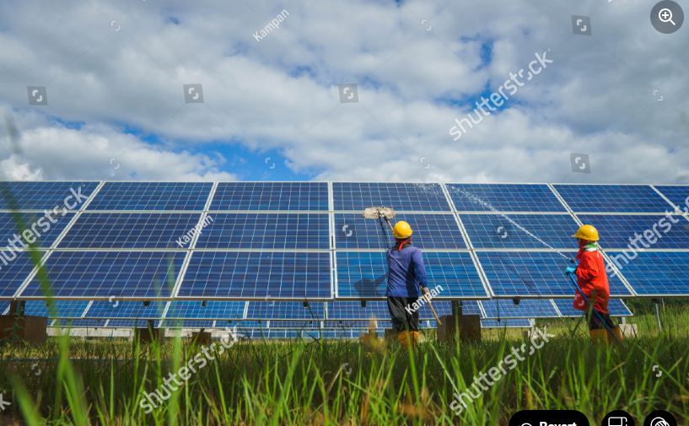
https://www.shutterstock.com/image-photo/view-solar-farmsolar-panel-alternative-electricity-1552354658
How do I monitor the performance of my solar PV system?
Regularly monitoring the performance of your solar photovoltaic system is crucial to ensure its optimal operation and energy production and to quickly identify and address any potential problems. Many solar PV suppliers offer remote monitoring services as part of their installation package, allowing you to keep track of your system's performance online. This remote monitoring typically provides real-time data on energy production, voltage, and temperature, as well as alerts for any issues.
In addition to remote monitoring, maintenance for solar PV systems is generally simple, and periodic removal snow and dust from panels can help maintain their efficiency. Regular inspections to check for any signs of damage or shading are also recommended.
_______
This brochure was produced with the assistance of the European Union under the EU4Energy Initiative. The contents are the sole responsibility of TBC Leasing and can in no way be taken to reflect the official opinion of the European Union.


